Lesson Title: Real World
Summary
Real world applications to linear functions
Sections in the textbook | I Can Statements
7th Grade  Sections 3.1, 3.2: Rates and Slopes  8th Grade  Sections 4.3, 4.4: Functions | 7th Grade  - I can use rates to describe a real-life situation.  - I can find the unit rate in tables, graphs, equations, diagrams, and descriptions.  - I can find the unit rate in tables, graphs, equations, diagrams, and descriptions.  8th Grade  - I can create the equation, table, or graph for a real-life situation (linear only)  - I can describe a relationship as increasing or decreasing from an equation, table, or graph
Skill Focus | Vocabulary Focus
 | slope, rate of change, unit rates, increasing, decreasing, y-intercept, initial value, slope-intercept equation.
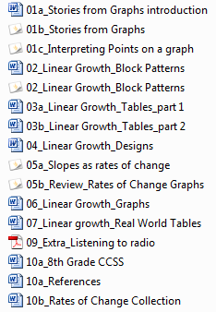
Materials:

Make a list of stories your students can relate to and appropriate units of measure.
(Example: drinking a soda, collecting wristbands, etc.)
____________________________________________________________________
____________________________________________________________________
____________________________________________________________________
____________________________________________________________________
____________________________________________________________________
____________________________________________________________________

Section 3.1
7th grade CCSS book

