**Notes: Linear Growth using Stacking Towers**

slope – intercept form of a line : 

*in other words . . .* 

**Example 1:**

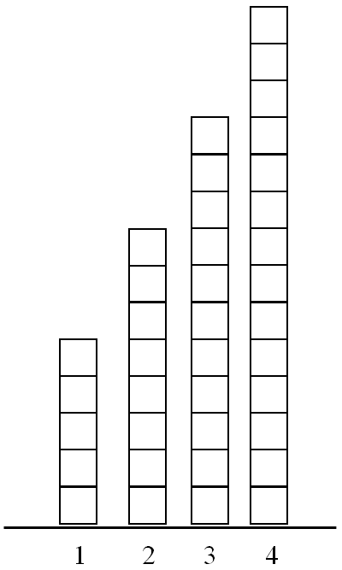



How is the pattern changing **(*m*)** ? _______

How many piece(s) were there in the beginning - step 0 **(*b*)** ? _______

Write an equation *y* = **m***x* + **b** to represent the pattern _________________

**Example 2:**

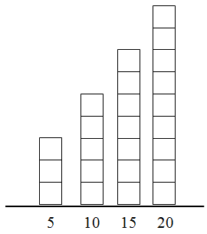



How is the pattern changing **(*m*)** ? ________

How many piece(s) were there in the beginning - step 0 **(*b*)** ? ________

Write an equation *y* = **m***x* + **b** to represent the pattern __________________

**Example 3:**

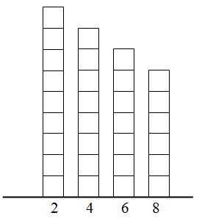



How is the pattern changing **(*m*)** ? ________

How many piece(s) were there in the beginning - step 0 **(*b*)** ? ________

Write an equation *y* = **m***x* + **b** to represent the pattern __________________

**Example 4:**

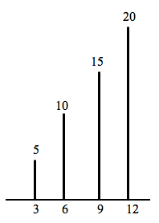

How is the pattern changing **(*m*)** ? ________ 

How many piece(s) were there in the beginning - step 0 **(*b*)** ? ________

Write an equation *y* = **m***x* + **b** to represent the pattern __________________

Name: ________________________

Period: _______ Date: __________

**Assignment: Linear Growth using Stacking Tower**

Problem 1:

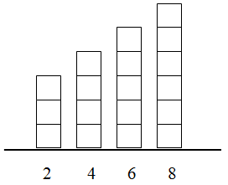



How is the pattern changing **(*m*)** ? ________

How many piece(s) were there in the beginning - step 0 **(*b*)** ? ________

Write an equation *y* = **m***x* + **b** to represent the pattern __________________

Write Equations for each linear growth pattern.

Problem 2: Problem 3: Problem 4:

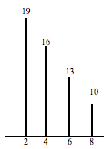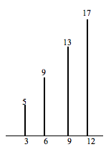

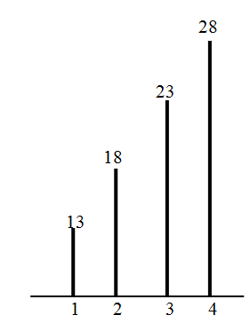

Equation: _______________ Equation: _______________ Equation: _______________

Problem 5: Problem 6: Problem 7:

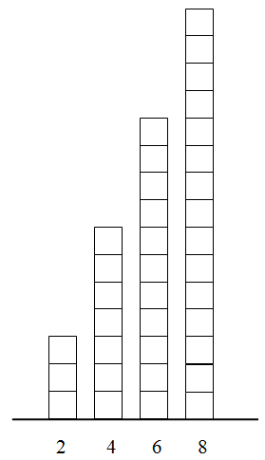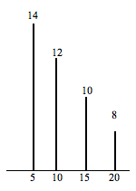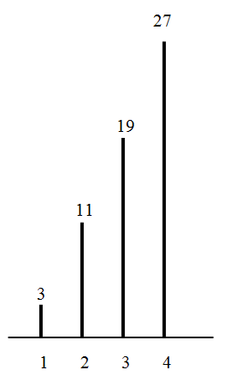

Equation: _______________ Equation: _______________ Equation: _______________

Create **3** drawings of linear growth patterns.

One must have a positive slope and one must have a negative slope.

Problem 8: Problem 9: Problem 10:

Equation: _______________ Equation: _______________ Equation: _______________

**Notes: Linear Growth using Stacking Towers**

slope – intercept form of a line : 

*in other words . . .* 

**Example 1:**





How is the pattern changing **(*m*)** ? ___  ____

How many piece(s) were there in the beginning - step 0 **(*b*)** ? ___ 2 ____

Write an equation *y* = **m***x* + **b** to represent the pattern ___ ___

**Example 2:**





How is the pattern changing **(*m*)** ? ___  ____

How many piece(s) were there in the beginning - step 0 **(*b*)** ? ___ 1 ____

Write an equation *y* = **m***x* + **b** to represent the pattern ___ ___

**Example 3:**





How is the pattern changing **(*m*)** ? ___  ____

How many piece(s) were there in the beginning - step 0 **(*b*)** ? ___ 10 ____

Write an equation *y* = **m***x* + **b** to represent the pattern ___ ___

**Example 4:**



How is the pattern changing **(*m*)** ? ___  ____

How many piece(s) were there in the beginning - step 0 **(*b*)** ? ___ 0 ____

Write an equation *y* = **m***x* + **b** to represent the pattern _ ___

or 

Name: ________________________

Period: _______ Date: __________

**Assignment: Linear Growth using Stacking Tower**

Problem 1:





How is the pattern changing **(*m*)** ? ___ ____

How many piece(s) were there in the beginning - step 0 **(*b*)** ? ___ 2 _____

Write an equation *y* = **m***x* + **b** to represent the pattern_ ___

Write Equations for each linear growth pattern.

Problem 2: Problem 3: Problem 4:



Equation: _  __ Equation: _  __ Equation: _  __

Problem 5: Problem 6: Problem 7:



Equation: _  __ Equation: _  __ Equation: _  __

_  __ _  __

Create 3 drawings of linear growth patterns.

One must have a positive slope and one must have a negative slope.

Problem 8: Problem 9: Problem 10:

Equation: _______________ Equation: _______________ Equation: _______________