**Notes: Linear Growth using Tables (part 2)**

***Review***

 *in other words . . .* slope – intercept form of a line : 

*y vertical axis*

*x horizontal axis*

Find the equation from the Table. ***y = change (x) + beginning.***

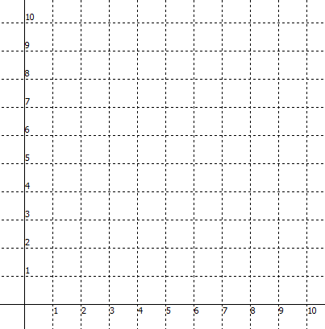**Example 1:**

Graph the points in the table.

|  |  |
| --- | --- |
| ***x*** | ***y*** |
| 0 | 1 |
| 1 | 3 |
| 2 | 5 |
| 3 | 7 |
| 4 | 9 |

How is the pattern changing **(*m*)** ? ________ 

Where does the pattern touch the *y* - axis - step 0 **(*b*)** ? ________

Write an equation *y* = **m***x* + **b** to represent the pattern __________________

**Example 2:**

Graph the points in the table.

|  |  |
| --- | --- |
| ***x*** | ***y*** |
| 0 | 3 |
| 2 | 4 |
| 4 | 5 |
| 6 | 6 |
| 8 | 7 |

How is the pattern changing **(*m*)** ? ________ 

Where does the pattern touch the *y* - axis - step 0 **(*b*)** ? ________

Write an equation *y* = **m***x* + **b** to represent the pattern __________________

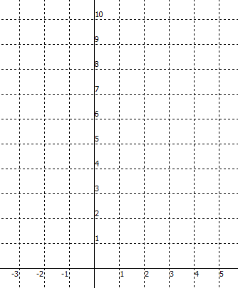**Example 3:**

Graph the points in the table.

|  |  |
| --- | --- |
| ***x*** | ***y*** |
| -2 | 1 |
| 0 | 4 |
| 2 | 7 |
| 4 | 10 |

How is the pattern changing **(*m*)** ? ________ 

Where does the pattern touch the *y* - axis - step 0 **(*b*)** ? ________

Write an equation *y* = **m***x* + **b** to represent the pattern __________________

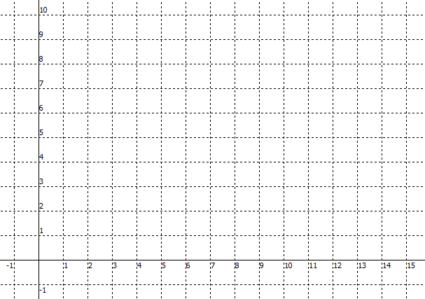**Example 4:**

|  |  |
| --- | --- |
| ***x*** | ***y*** |
| 3 | 8 |
| 6 | 6 |
| 9 | 4 |
| 12 | 2 |
| 15 | 0 |

How is the pattern changing **(*m*)** ? ________ 

Where does the pattern touch the *y* - axis - step 0 **(*b*)** ? ________

Write an equation *y* = **m***x* + **b** to represent the pattern __________________

**Example 5:**

|  |  |
| --- | --- |
| ***x*** | ***y*** |
| -4 | 23 |
| -2 | 20 |
| 0 | 17 |
| 2 | 14 |
| 4 | 11 |

Write an equation *y* = **m***x* + **b** to represent the pattern __________________

**Example 6:**

|  |  |
| --- | --- |
| ***x*** | ***y*** |
| 5 | 14 |
| 10 | 16 |
| 15 | 18 |
| 20 | 20 |
| 25 | 22 |

Write an equation *y* = **m***x* + **b** to represent the pattern __________________

**Assignment: Linear Growth using Tables (part 2)**

Name: ____________________________

Period: _______

Date: ________

Write the equation from the Table. ***y = change (x) + beginning.***

X Y X Y X Y

0 4 -2 -5 -4 12

1 6 0 0 0 9

2 8 2 5 4 6

3 10 4 10 8 3

y = _____________ y = ______________ y = ___________

X Y X Y X Y

3 21 5 -19 -1 -1

6 25 10 -13 0 4

9 29 15 -7 1 9

12 33 20 -1 2 14

y = _____________ y = ______________ y = ____________

X Y X Y X Y

-1 4 2 10 -3 14

1 8 4 5 0 15

3 12 6 0 3 16

5 16 8 -5 6 17

y = _____________ y = ______________ y = ____________

Fill out a table of values for the graph, then write the equation of the line that passes through the points.

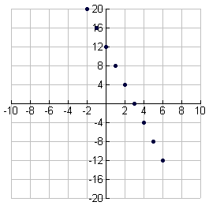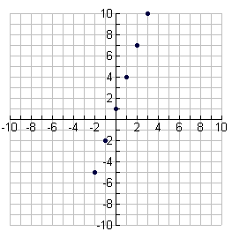

|  |  |
| --- | --- |
| X | Y |
|  |  |
|  |  |
|  |  |
|  |  |
|  |  |
|  |  |
|  |  |
|  |  |
|  |  |

|  |  |
| --- | --- |
| X | Y |
| -2 | -5 |
|  |  |
|  |  |
|  |  |
|  |  |
|  |  |

y = __________________ y = _________________