**Notes: Linear Growth using Graphs**

***Review***

**Identify the *y-intercept* and *slope* of each equation, then draw the graph.**

*(Write slopes in fraction form)*

1.  2.  3. 

*(y – intercept)* b =  *(y – intercept)* b =  *(y – intercept)* b =

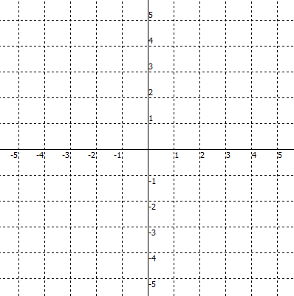 *(slope)* m =  *(slope)* m =  *(slope)* m = 

**Identify the *y-intercept* and *slope* of each graph, then write the equation.**

4. 5. 6.

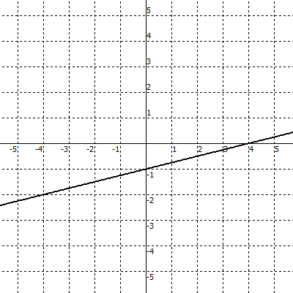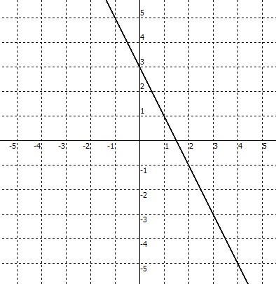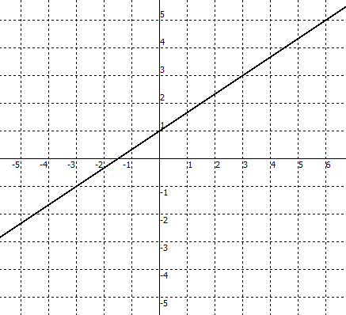

*(y – intercept)* b =  *(y – intercept)* b =  *(y – intercept)* b =

*(slope)* m =  *(slope)* m =  *(slope)* m = 

equation: ____________ equation: ____________ equation: ____________

**Interpreting Graphs**

slope – intercept form of a line : *y =* ***m .*** *x +* ***b***

*in other words . . . y =* ***(rate of change)****x +* ***beginning***

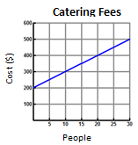

What does the *y*-intercept represent?

Beginning value - step 0 **(*b*)** ? _______

Rate of change **(*m*)** ? _____________

Write an equation *y* = **m***x* + **b**

to represent the pattern _________________

What does the *y*-intercept represent?

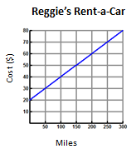

Beginning value - step 0 **(*b*)** ? _______

Rate of change **(*m*)** ? _____________

Write an equation *y* = **m***x* + **b**

to represent the pattern _________________

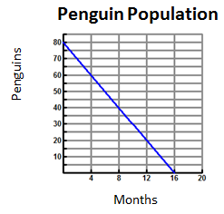

What does the *y*-intercept represent?

Beginning value - step 0 **(*b*)** ? _______

Rate of change **(*m*)** ? _____________

Write an equation *y* = **m***x* + **b**

to represent the pattern _________________

What does the *x*-intercept represent?

**Interpreting Graphs - Assignment**

Name: ________________________

Period: _______ Date: __________

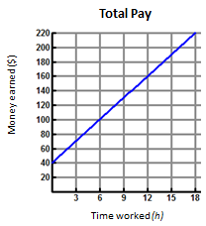

1) What does the *y*-intercept represent?

Beginning value - step 0 **(*b*)** ? _______

Rate of change **(*m*)** ? _____________

Write an equation *y* = **m***x* + **b**

to represent the pattern _________________

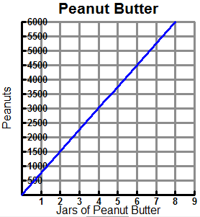

2) What does the *y*-intercept represent?

Beginning value - step 0 **(*b*)** ? _______

Rate of change **(*m*)** ? _____________

Write an equation *y* = **m***x* + **b**

to represent the pattern _________________

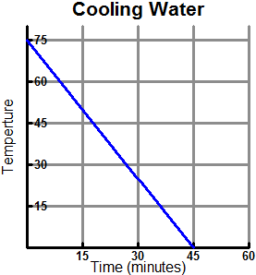

3) What does the *y*-intercept represent?

Beginning value - step 0 **(*b*)** ? _______

Rate of change **(*m*)** ? _____________

Write an equation *y* = **m***x* + **b**

to represent the pattern _________________

What does the *x*-intercept represent?

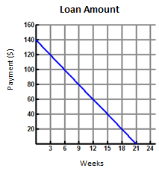4) What does the *y*-intercept represent?

Beginning value - step 0 **(*b*)** ? _______

Rate of change **(*m*)** ? _____________

Write an equation *y* = **m***x* + **b**

to represent the pattern _________________

What does the *x*-intercept represent?

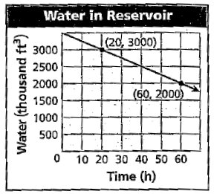5) What does the *y*-intercept represent?

Beginning value - step 0 **(*b*)** ? _______

Rate of change **(*m*)** ? _____________

Write an equation *y* = **m***x* + **b**

to represent the pattern _________________

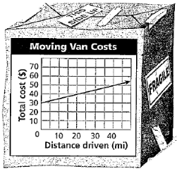6) What does the *y*-intercept represent?

Beginning value - step 0 **(*b*)** ? _______

Rate of change **(*m*)** ? _____________

Write an equation *y* = **m***x* + **b**

to represent the pattern _________________

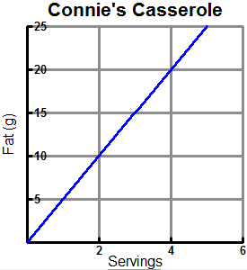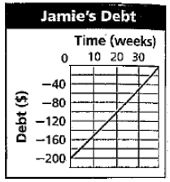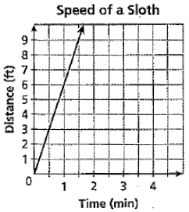

7) What does the *y*-intercept represent?

Beginning value - step 0 **(*b*)** ? _______

Rate of change **(*m*)** ? _____________

Write an equation *y* = **m***x* + **b**

to represent the pattern _________________

8) What does the *y*-intercept represent?

Beginning value - step 0 **(*b*)** ? _______

Rate of change **(*m*)** ? _____________

Write an equation *y* = **m***x* + **b**

to represent the pattern _________________

What does the *x*-intercept represent?

9) What does the *y*-intercept represent?

Beginning value - step 0 **(*b*)** ? _______

Rate of change **(*m*)** ? _____________

Write an equation *y* = **m***x* + **b**

to represent the pattern _________________

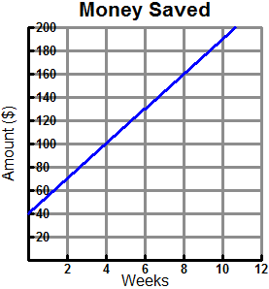

10) What does the *y*-intercept represent?

Beginning value - step 0 **(*b*)** ? _______

Rate of change **(*m*)** ? _____________

Write an equation *y* = **m***x* + **b**

to represent the pattern _________________

What does the *x*-intercept represent?