Name: ______________________

Period: ____

**Warm-up: *before* Interpreting Graphs**

**Identify the *y-intercept* and *slope* of each equation, then draw the graph.**

*(Write slopes in fraction form)*

1. 2. 3.



*(y – intercept)* b =  *(y – intercept)* b =  *(y – intercept)* b =

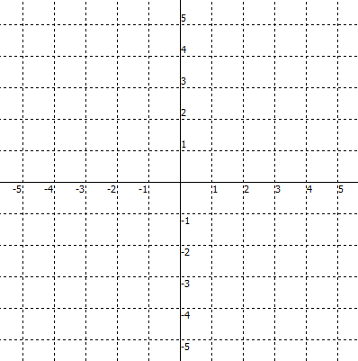 *(slope)* m = *(slope)* m = *(slope)* m =



**Identify the *y-intercept* and *slope* of each graph, then write the equation.**

4. 5. 6.

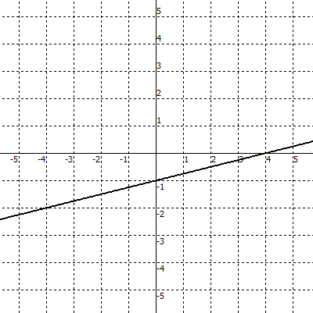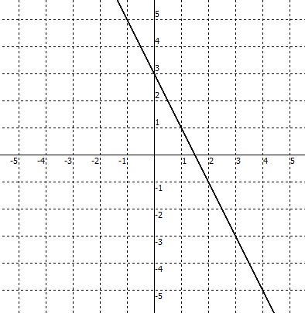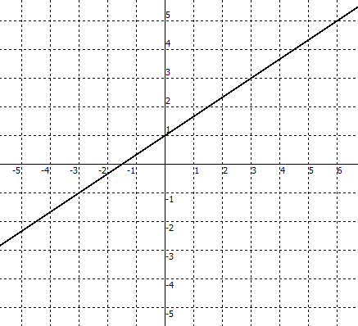

*(y – intercept)* b =  *(y – intercept)* b =  *(y – intercept)* b =

*(slope)* m = *(slope)* m = *(slope)* m =



equation: ____________ equation: ____________ equation: ____________

Algebra 2 Interpreting Graphs A day (Jan 17) B day (Jan 18)

slope – intercept form of a line : *y =* ***m .*** *x +* ***b***

*in other words . . . y =* ***(rate of change)****x +* ***beginning***

1. a) What does the *y*-intercept on the graph represent?

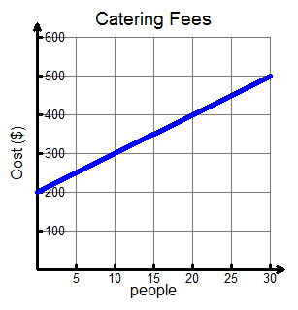

b) Beginning value **(*b*)** ? _______

c) Rate of change **(*m*)** ? _____________

d) Write an equation *y* = **m***x* + **b** to represent the pattern

_________________________________________

e) Write the equation using function notation **C(p)** to

represent the pattern __________________________

f) Evaluate by reading the *graph*

C(10) = C(30) =

g) What does the expression C(20) represent?

h) Using the *function* **C(p)** written in step *e*, predict the catering fees if there are

500 people (show your work) 2,000 people (show your work)

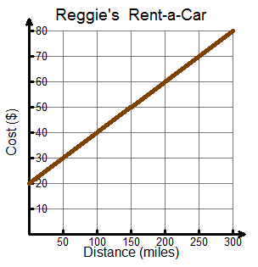

2. a) Beginning value **(*b*)** ? _______

b) Rate of change **(*m*)** ? _____________

c) Write the equation using function notation C(m) to

represent the pattern _____________________

d) What does the expression C(100) represent?

f) Evaluate by reading the *graph*

C(0) = C(200) =

g) Using the *function* C(m) written in step c, predict the rental fees if a car is driven

1500 miles *(show your work)*  5500 miles *(show your work)*

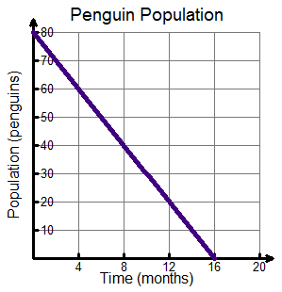3. Given a graph representing penguin population, P(t).

a) Evaluate by reading the *graph*

P(0) = P(4) =

b) What does the expression P(0) represent?

c) Rate of change **(*m*)** ? _____________

d) Write the equation using function notation P(t) to

represent the linear pattern _____________________

e) Using the graph, *estimate* the value of P(6).

f) Using the *function* P(t) written in step *d,* determine the penguin population at

6 months (show your work)

Does your answer for *part f* match your estimate in *part e* ?

g) What does the *x*-intercept represent?

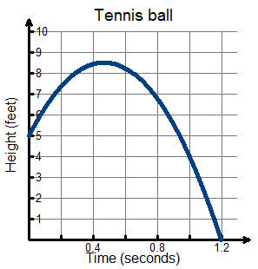4. The graph represents the height of a tennis ball thrown upward.

a) What does the *y*-intercept represent?

b) Evaluate by reading the *graph*

h(0) = h(0.3)  h(1) =

c) What does the expression h(0.3) represent?

d) Estimate the highest height the tennis ball reaches.

e) Estimate the time the tennis ball reaches its highest height.

f) What does the *x*-intercept represent?

**Interpreting Graphs - Assignment**

Name: ________________________

Period: _______ Date: __________

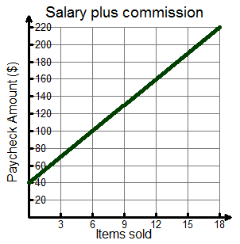

1. a) What does the *y*-intercept represent?

b) Beginning value **(*b*)** ? _______

c) Rate of change **(*m*)** ? _____________

d) Write the equation using function notation P(i) to

represent the pattern _____________________

e) What does the expression P(10) represent?

f) Evaluate by reading the *graph*

P(6) = P(12) = P(0) =

g) Using the *function* P(i) written in step *d*, evaluate the total pay for the items sold

40 items *(show your work)*  100 items *(show your work)*

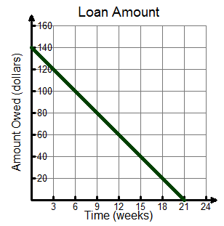

2. Given a graph representing a Loan Amount, L(t).

Determine the following:

a) Determine L(0) : _______

b) Rate of change **(*m*)** ? _____________

c) Write the equation using function notation L(t) to

represent the pattern _____________________

d) What does the expression L(12) represent?

f) Using the *function* written in step *c*, determine the amount owing on the loan

6 weeks *(show your work)*

Does your answer for *part f* match the graph ?

e) What does the *x*-intercept represent?

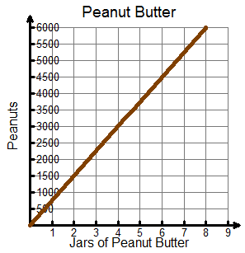3. a) Beginning value **(*b*)** ? _______

b) Rate of change **(*m*)** ? _____________

c) Write the equation using function notation P(j) to

represent the pattern _____________________

d) What does the expression P(4) represent?

e) Estimate by reading the *graph*

P(7)



f) Using the *function* written in step *c*, predict the amount of peanuts needed for the given number of jars

20 jars *(show your work)* 100 jars *(show your work)*

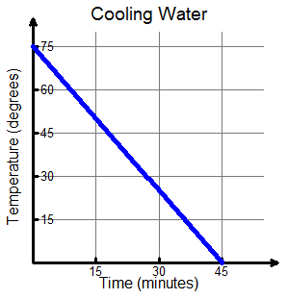

4. Given a graph representing temperature of water, T(m).

a) What does the *y*-intercept represent?

b) Rate of change **(*m*)** ? _____________

c) Write the equation using *function notation* to

represent the pattern _____________________

d) Estimate by reading the *graph*

T(15) 

e) Using the *function* written in step c, determine the exact temperature of the water

15 minutes (show your work)

Does your answer for *part e* match your estimate in *part d* ?

f) What does the *x*-intercept represent?

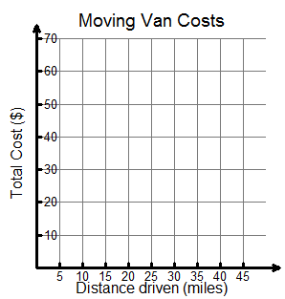5. Given a graph representing a Moving Van Costs, C(m).

a) Graph the given points

C(0) = 30

C(20) = 40

C(40) = 50

b) Determine the rate of change **(*m*)** ? _________

c) Write the equation using function notation C(m) to

represent the pattern _____________________

d) Using the *function* C(m) written in step c,

predict the fees of renting a moving van for the given distances

100 miles 2,000 miles

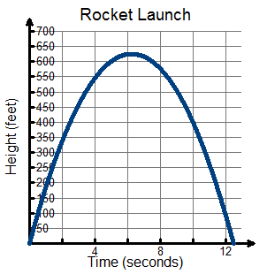6. The graph represents the height of a rocket shot up into the sky.

a) What does the *y*-intercept represent?

b) Estimate the height of the rocket at 2 seconds

c) Estimate the height of the rocket at 8 seconds

Given the equation of the graph is



d) Evaluate function for the following values

Show your work!

h(0) = h(8) =

e) Estimate the highest height of the rocket

f) Estimate the time the rocket reaches its highest height

g) Estimate the time (in seconds) the rocket is at a height of 450 feet. *(Hint: there are two answers)*

h) What does the *x*-intercept represent?